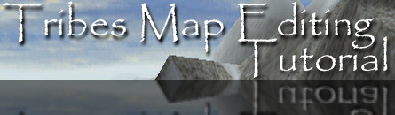
By: Omnipotent
This tutorial is made for Tribes 1.9

This tutorial is meant to take Tribes players one more step further into the game than simply playing it. Before I start, let me explain why I chose to write this tutorial. The number one reason I wrote this tutorial is because most other tutorials are out dated or incomplete. This tutorial is also a project for myself. I have been mapping since I got the game and hope that you find my experience beneficial in the Tribes mapping community.

I also suggest that you do some preparations before you start making your first or any map. I suggest that you do get some good music going when editing. An MP3 play list is good or you can turn on any stereo that is near by. You may also want to open a window or do some activities (can’t go play a game of Tribes) before editing. If your editing at night get an alarm clock, you’re going to find it’s midnight before you know it.

Section I - Getting To The Editor

Opening the map editor is very simple yet unknown to most players. The map editor is a built in feature of Tribes. So lets fire up Tribes. Start a server with your chosen terrain.

*NOTE* - Once you have chosen a terrain for your server-side map, go into Windows Explorer and make a copy of the .mis and .dsc files (X:\Tribes\Base\Missions). Rename the copies to the name of your choice.

If you are currently online, it is a good idea to enable a password on your server so people don't join while you're building your map. Once the server is running, set the time limit to infinite (your map will not change while you're editing the map).

First go to the console screen by pressing "~" (Tilde). From the console type the command “exec(editor);”. The screen should go blank. Don't worry, this happens to everyone. To get out of this situation all you need to do is push key 6, and hold down E key until you see the terrain under you.

*NOTE* - If you are making a client-side map you want first to type in the command “exec(editmission);”. Make sure that you are in window mode. You shouldn't use this command if you want to make a server-side map.

Section 2 - Movement in the editor

Now you’re in the editor, but you don’t feel safe pressing all the buttons until you start moving around. I’m going to explain all the commands.

Command | Action | Command | Action | Command | Action
W | Move Forward | 1-0 | Move Speed | F1 | Hide Windows
S | Move Back | Ctrl 1-0 | Set Bookmark | F2 | Inspector mode
A | Move Left | Alt 1-0 | Go to Bookmark | F3 | Creator Mode
D | Move Right | Ctrl-X | Cut | F4 | Terrain Mode
E | Move Up | Ctrl-C | Copy | F5 | Walkthrough Mode
C | Move Down | Ctrl-V | Paste | F9 | Help
O | Options | Ctrl-D | Duplicate | Ctrl-S | Save
Ctrl-Z | Undo | Ctrl-Delete | Delete Object | Ctrl-N | New Group
Left Click | Select Object | Right Click | Hold and move to Rotate view
Ctrl-Left Mouse | Move object Vertically | Shift-Left Mouse | Rotate Object Side Ways | Alt-Left Mouse | Rotate Object Up & Down

*NOTE* - Some of these commands work differently or don’t even work in some modes. Mainly in TED the Left Mouse bottom only selects and applies actions, and does not rotate or move objects by Dragging.

In the editor there are also four different types of modes. They are as follows.

Inspector Mode (F2 Key) - This is where you will do most of your positioning and modifying of objects (Also where you are when you first enter the editor). You can also rename your object to whatever you want in this mode.

Creator Mode (F3 Key) - This is where you will do all of your object adding.

Terrain Editor Mode (F4 Key) - This mode is better known as TED. TED stands for Tribes Editor. This is where you will create and modify your landscape. *Caution* - Only use this mode if your working with client-side maps.

Walkthrough Mode (F5 Key) - This is the game-testing mode. Most everything will display or behave as if you are actually playing the game. This is also the only way to get back into tribes.

Section 3 – Editing The Terrain

*Note* - Read this Section only if you wish to make a client-side map. If you want to make a server side map just skip over to Section 4, but I suggest you read this section for knowledge. Just remember that some tools should only be used in client-side maps.

Making A New Terrain

So, you want to make a client-side map. I was going to write this huge section on how to make a new terrain, but as you may have known, Dynamix has integrated a terrain generator in the editor. This makes it extremely easy to make a new terrain, as you can see in the picture below.

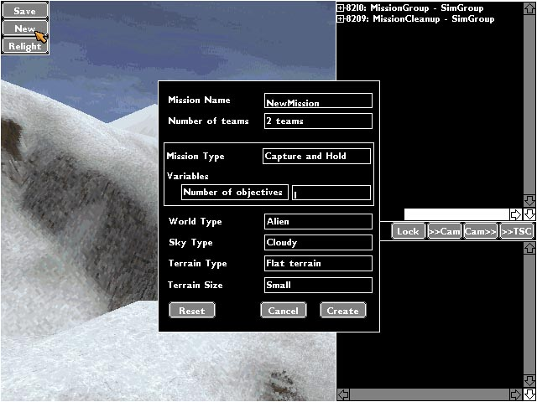

All you have to do is click on New, which is located in the upper-left hand corner of the editor and then fill in all the fields. I don’t know why some newer tutorials tell you to use the command line “exec(newmission);” when you got a perfectly good button right there.

The old way would have taken an hour to get right. You better thank Dynamix for adding this feature though the old way would get you the exact terrain you want from the amount of curve in the hills to the amount of sloop in the mountains.

Pinning The Terrain

To pin the terrain means to have the terrain not morph (locked) when viewed from a distance. This decreases performance if you were to pin the whole map.

Instead you are going to pin the areas around your bases or bunkers. The first thing you need to do is make sure that the TED window is open. If you do not have it open you need to disconnect then reconnect and type exec(editmission); before exec(editor);. You should now see the TED window open up. In Tribes, move over to the base you want to pin. In the editor press F4 to enter the terrain editor mode. In the TED window you will see a field saying “Level 0”. Change the property to Level 1 or 2. Then Click on the little icon of a blue pin. Then click back into Tribes. You should see you cursor surrounded with some boxes that go over the terrain. Start clicking around your base.

Deleting Terrain

You’re making client-side maps and you added a base that goes underground and noticed that the terrain doesn’t allow you to enter the lower parts of your base.

Well, we can fix that. I hope you loaded TED. If not, don’t bother trying now if you’re in the editor. Just save what you have done so far and disconnect from your map and reconnect. Once you are back in the map go to the console and type in the command “exec(editmission);” then type in “exec(editor);”. Now that the TED window is open lets move to the base that had the terrain problem. You should be in the Terrain Editor Mode (F4) and you should then see a box wherever your curser goes. Click where the terrain causes the problem. Then in TED select FlagMask from the Value Menu. Select Empty1 and hit OK. Then select SetFlags from the Selection Menu. Your terrain should be gone. If you find that you deleted too much terrain just click on the empty spaces you want back and choose Remove Flags from the Selection Menu.

Making A Flat Terrain

Some of you may have been wonder why the flat terrain that the generator makes is still a bit bumping. This section will show you how to get that extremely flat terrain that everyone wants. This is a fairly easy task but is not know by that many people.

To make a flat terrain you need to have the TED window open. You can do this by entering exec(editmission); before executing the editor. After you have moved the TED window out of you way go into F4 mode. Now choose your plot of land that you wish to make flat. After that, look in the TED window and under the values menu click on Set Values. A new window should pop up and by default should be at 50. You can set it to any number you want. For my map Dessert Road for the Counter-Terrorist Mod I set the mesa at 250. You can set it lower if you wish. This makes it very hard to get back up if you would fall. Okay, after you have set you height number look under the selection menu and click on setHeight. It is better to use this technique with level1 detail and up. Remember that the higher you make your terrain the more the terrain texture is going to stretch. Thus making it very ugly in software mode an almost impossible to run up the stretch.

This concludes making a new terrain and most other terrain features.

Section 4 - Adding objects

In this section I will show you how to add objects to your map. I will also tell you which objects will cause your Tribes to crash.

To add an object to your map is easy, but first I want to have you insure something. In the editor press O (that’s O as in Only). This makes a black window pop up in the editor. This is what the option screen looks like.

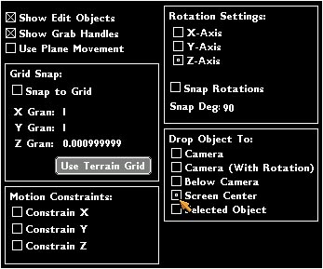

The real reason your looking at the option screen is, to see if in the lower right hand corner of the window in the box labeled “drop object to” is set to “screen center”. This insures that when you add the object it will not end up in the air or where the camera is set.

The first thing you need to do is hit F3. This will take you to the creator mode. Just move to where you want to build your base. I always try to find a place where is generally flat so it is easier to place objects without worrying about having to take 2-5 minutes just to make your object perfect or near perfection.

*Note* - If your making a client-side map do not worry about making you bases perfect because you can always delete the terrain or lower and raise the terrain.

I’m going to first get you started in 4 sub-sections.

Adding Team Objects

Have you ever wondered why you can’t go in the enemies inventory station? Well, you shouldn’t since it tells you in the chat log why you can’t use them. In this area I’m going to show you how to make a object a team object. Lets get that base you wanted on a team. Go in the following directory in the editor.
+ Mission Group
+ Teams
+ TeamX (X being the team number)
Once in the directory, you can start adding what you want in the area you selected. Remember, when you delete an object you are put back in the main directory. So, you have to click back on the team directory to add team objects again.

Organizing Your Objects

Mapmakers do not require this area though I will still explain how to organize your objects.

Start off by making a MissionGroup. If you forgot how to create a MissionGroup it is Crtl+N. To add a MissionGroup is the same process as adding a object. This means you have to go in:
+Teams
+ Team (X).
Highlight Teams (X) and then press Crtl+N. This will give you a new group. Go into inspector mode and change the name of the group to lets say BaseGroup. Remember press apply or the affects will not take place. You can start adding your objects that are related to your main base there. Remember because you have a generator in Team (X) does not mean it will give power to the objects in BaseGroup. Make sure you are giving power to your new group.

*Note* - I read somewhere that the generators have a power giving distance. I’m not sure how far each generator produces, but I am sure the bigger the generator is, the larger the radius of power will be.

Adding A Drop Point

A drop point is where you start off in a map. It is best to add one starting drop point and one random drop point during construction of your map. This helps getting back to construction instead of wasting time returning to your base.

Open the following directories in creator mode.
+ Mission Group
+ Teams
+ Team0
+ Drop Points
+ Start

In the start section (highlight it) place your drop points wherever you want in your base. The drop point is located under Mission then Drop Point. It is a good idea to have 3-drop points in a row and spread the groups of drop points apart as I have done in this map below.
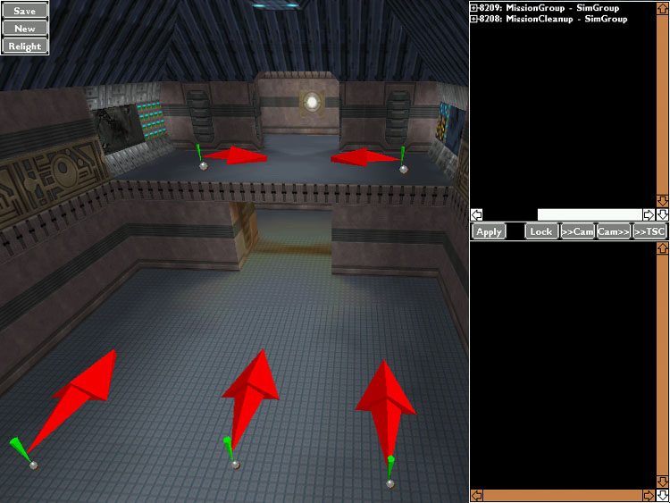

When I was first making maps, I was told to have a maximum of drop points for each team to 16 due to some lag issue and that most servers only go to 32 players max. Well, I suggest that you put around 9-11 of those drop points on the starting and the rest on random. Most maps will have the two-drop point sections already in the map so just delete the old drop points with the Crtl+Delete command and then add yours. If your map is just moving some objects around from a base map (Scarabrae, RollorCoaster and so on) then just leave the drop points alone or move them to your likings.

You’re probably wondering what the green arrow and the red arrow are. The green arrow is just a mark of where the player will show up. The red arrow shows which direction the player will be facing.

Section 5 - Adding Advanced Objects

This section is going to explain to you on how to add advance objects in the editor. I will start from easiest to hardest in my opinion.

Adding Stations That Any Team Can Use

To make a station usable for both teams is easy if you are familiar with the editor.

Under MissionGroup make a new SimGroup. To make a new SimGroup press Crtl+N. Go into inspector mode and change the name to whatever fits the scenario. I suggest calling it Neutral. Do not forget to press apply or the affects will not stay. You can start adding stations to the SimGroup. Don’t forget to add a generator in the SimGroup. If you want your station(s) to always be powered just place the generator(s) under the terrain. This way they cannot be powerless.

*Note* - Neutral objects can be destroyed by any team

Adding Weather and Star Fields

Adding weather and star fields can greatly improve game play while making the player feel a more realistic surrounding. Though weather can and might decrease performance while playing due to the CPU having to work harder to render weather. One thing to remember when adding weather make sure in your graphic option is setup so weather is shown.

Adding Weather Affects

In Tribes there are two types of weather affects. They are snow and rain. To add snow and rain is exactly the same process. Remember; don’t add snow to a map where the terrain is lush such as raindance. Add weather that fits the condition of your map.

Lets start adding weather affects. Enter creator mode (F3) and go in the directory MissionGroup. Once there go to Sky, which is under Mission. Here you will either choose rain or snow.

There is still one thing that you can adjust. Go in inspector mode (F2) and click on rain1 – Snowfall. You should see Snowfall Intensity and Snowfall Wind Direction. Don’t ask me why it says snowfall for the rain affect but it really doesn’t matter. Don’t worry about intensity, since if you change it, it will just reset back to 1. However you can change Snowfall Wind Direction. You should see 0 0. The first number directs the rain to the East, while the second number directs the rain to the North.

*Note* - For some reason you cannot change the wind direction of snowfall. I have also noticed that after 6 I see no difference in wind direction.

Adding A Star Field

Star fields are a must for night maps in my opinion. Remember, to add stars it should only be on night missions. If you plan on adding them in day mission you might see them but they don’t seem to say I’m a professional mapmaker and that’s not what we want to do. It should be easy to add a star field, because it’s the same process as adding a weather affect. Now that you’ve added your star field in the landscape group you can now go in to inspector mode (F2). Once there you will see a lot more options then for weather. There isn’t much to change unless you want to make your stars a different color than white. What you want to do here is make sure that “Render Stars in Front” is checked. What this does is makes the player’s computer only render the stars he/she is viewing. This increases performance, which makes your maps more enjoyable.

Adding Doors and Force Fields

In this section I will explain how to add doors and force fields to your maps. Adding doors is very simple since Dynamix added macros into the editor in one of the patches. They also added force field macros but I do not suggest that you use them since they do not work very well. I will first show you how to add doors than force fields.

Adding doors

To add a door is has simple as adding a regular object. First choose the team you want the door to be on. Create a new simgroup and name it to Door or whatever you feel comfortable with. In that group add a generator and place it wherever you wish. If you want the door to be powered by the main generator then do not make a new simgroup. In the group that you selected to use, go in creator mode and add your door. The doors are under DoorMacros. Once you add them you should see 3 makers pop up at where you are looking. Where is the door that you just added? Well you’re looking at it. You need to save, exit, and reconnect. This should make it so that your new door is visible. I have found that going into an inventory station or something that takes your vision of the game will make it show up without disconnecting. This should be enough for adding doors. If you want a good example of a door you can check out Pokey’s Ski Zone.

Adding Force Fields

Adding a force field is a lot more complicated than adding a door since I find that the force field macro isn’t working and just lets you walk through it. Instead I’m going to tell you the old fashion way of adding force fields.

In the editor find where you want to put your force fields. Then once you’ve decided where you want to place the force field you need to go into inspector mode. Once there you need to create a group for your force field. You should then rename the group to something like Door, Force Field, Front Door, etc… You should make sure that the force field is powered. I suggest using a solar powered generator and do not place it underground unless needed.

Now that you’ve given power to your group you need to add another group into your already existing group called Path1. If you actually took the time to notice other maps with force fields you should have noticed that the Path1 group is a SimPath and not a SimGroup that is on your screen. You should not worry about the difference yet. I will explain it later on in the tutorial.

Now that you’ve got your Path1 group you need to add two markers (they can be found in the mission group in the creator mode). These markers are not the pathmarkers, but markers. The markers should have three different arrows each a different color (Red, Green, Blue).

The red arrow is nothing important, but helps you rotate the marker.

The green arrow points to the direction your force field will be. If you want your force field to be standing, then the arrow should be facing up. If you want it to lie on its side then you should have the marker rotated until the arrow is pointing to the side.

The blue arrow is like the string that connects the two markers. It also shows the movement of the force field. I suggest having this arrow pointing at the other marker.

You may be wondering why you just placed two markers under Path1. The first marker is where your force field will end up when it is open. The second marker is the area where your force field is when it is closed. You must make sure that you don’t mix this up or your force field will not work. The second marker is the only marker you need to mess around with in the editor. You will make the changes to the first marker in the .mis file. What happens with the force fields is that it kind of just slides right over from marker to marker. One thing to make certain is that your force field will not slide through an object or a room. If it slides through a room it will still work but someone who is looking at that room will see a force field fly through the room whenever someone opens or closes the force field. You may also want to make sure you don’t see your force field sticking out the side of a wall or your building. What you want to do is make sure to place the second marker in a thick wall that does not go through any obstacles or rooms.

Highlight your ForceField SimGroup (this is the group where you have “Path1” under). Then go into creator mode and go to the Doors group and select the desired force field (ForceField – ForceField 5x5). If you have an opening like the one on RollerCoaster than I suggest you use ForceField. To get an idea what the ForceField is like size matter just go to misc. and select Force Field. This is the same size but this does not require a generator and does not open and close like a door force field. This may make you a little confused on why all you see is a little green dot in place of your highly anticipated force field. That little green dot is your force field for now. Just place it in the middle of the second marker. It doesn’t have to be perfect since we will make it centered in the .mis file. Make sure you have some kind of power source powering your force field. Once you’ve done that save and quit Tribes. Remember to quit Tribes there are two ways you can do that. First way is to go into the simulation mode and press Esc and press quit. The other way is to type in quit(); in the console screen.

The .mis file basically holds all the data that you see in the editor. So if you added a station in team1, you will see that station under team1. Open up your map .mis file. You can find it in your X:\Tribes\base\missions directory. The notepad editor is preferred, however if the file size is too large for Notepad, use WordPad but avoid using Microsoft Word as your .mis editor. Look for your force field group and look at what I have done for my force field in my map Jungle Strike.

Instant SimGroup "Doors" { Notes:
instant SimGroup "FlagDoor" {
instant SimPath "Path1" { <------Change to "SimPath" from "SimGroup"
isLooping = "False"; <------Add this line
isCompressed = "False"; <------Add this line
instant Marker "Marker1" {
dataBlock = "PathMarker";
name = "";
position = "578.149 243.224 169.426"; <------2 numbers will be the same. *note below
rotation = "0 -0 -2.19993"; <------Same as second marker below.
locked = "1";
};
instant Marker "Marker1" { <------This is your main marker. DO NOT mess
dataBlock = "PathMarker"; with these settings first time around.
name = ""; Adjust this after you go into the game
position = "578.149 243.224 169.426"; and see that your force field needs
rotation = "0 -0 -2.19993"; adjustments. You will use these settings
locked = "1"; to modify the first marker and the force field.
};
};
instant Moveable "DoorForceField1" {
dataBlock = "DoorForceField5x5";
name = "";
position = "578.149 243.224 169.426"; <------Copy from the second (main) marker.
rotation = "0 -0 -2.19993"; <------Copy from the second (main) marker.
destroyable = "True";
deleteOnDestroy = "False";
fadeTime = "0"; <------Add this line
center = "1"; <------Add this line
Status = "close"; <------Add this line
closeTime = "1"; <------Add this line
locked = "1";

Save the .mis file and quit notepad or WordPad. Then go and open up Tribes and host your map. Do not go in the editor just yet. First go to your force field to see if it is there. If it is, then give yourself a pat on the back. If it’s not there or doesn’t work then go and make sure it has power. If that’s not the case then go look in the .mis file and see if you forgot to change something. If you didn’t forget anything, then see if it’s caught on anything like a station or a flag or whatever that can get stuck on. If all else fails e-mail me. I think this is enough for force fields except I would like to give credit to Pokey for basically all the info on force fields that I know.

Section 6 – Finishing Up Your Map

You’ve made your map and everything is done. Except one thing. You want to put a briefing in the briefing page and maybe change the mission type to C&H instead of CTF. Well, here is where I’m going to show you how.

Changing the Mission Briefing

You need to close Tribes, but don’t forget to save. Once you’re in Windows you need to open up notepad and open your .dsc file. You can find this file in the same place as your .mis file. Look at what you have in front of you.

For the first line you should have this:
$MDESC::Type = "Mission Type here"; (Mission Type here = CTF, C&H, DM, D&D, F&R…). You can change the Mission type to what ever you want. Remember to spell out the mission type fully. Do not leave it has CTF, C&H, and so on.

For the second line you should have this:
$MDESC::Text = "<s3><f1>Mission Type: <f0> Mission Type" @. Once again the same thing goes for this one.

For the third line you should have this:
"\n<f1>Planet: <f0> Planet name here" @. You can change the planet name to what ever you want.

For the forth line you should have this:
"\n<f1>Weather: <f0> Weather Condition here" @. You can change the weather condition to whatever you want. Remember to keep the description of the weather to what the weather is like. On an Ice level don’t put something like raining and extremely hot.

For the fifth line you should have this:
"\n<f1>Time of Day: <f0> Night or Day" @. You can either choose Night or Day. You can put a more specific time of day then night or day.

For the sixth line you should have this:
"\n<f1># of Teams: <f0> 2 or more" @. You can change the amount of teams to whatever amount your map is setup with. Please if you don’t have more than two teams then don’t say 3 or more. If you put more than two teams then that places your map under the mission type of Multiple Teams.

For the seventh line you should have this:
"\n\n<f1>Briefing:<f0> Your briefing here";. You can place whatever you want for the briefing here. You can also place the story of your map here. I suggest you use the command <vServer::teamNameX> whenever you want to use the team name. What this does is use the server’s team names. If you have more than one team then just put the number of the team in place of X.

*Note* - If you made a new terrain you will see “\n\n<f1>Briefing:<f0> the greater the difficulty, the more the glory in surmounting it.";. You can just delete that and put in what you want for a briefing.

If you want to add something extra in the briefing such as “Thanks to” or “remember to go to”, just type in "\n\n<f1>What you want here:<f0> . This should be enough on changing the briefing of a map.

Changing the Mission Type and Score Limit

This section is not required but if you changed the mission type in the .dsc file you better read this. If you want to make a CTF mission into a C&H, first open up your .mis file. Then scroll down to the very bottom. You should see something like this

//--- export object end ---//
$teamScoreLimit = 8; ← Change this to what ever you want.
exec(objectives);
$Game::missionType = "CTF"; ← Change this to C&H, D&D, DM, F&R, MT.
$cdTrack = 7;
$cdPlayMode = 1;

Once you are done with this the last thing that you have to do is beta testing. Find some on-line buddies and play a game with them. Make sure to search everywhere around your base (if you deleted terrain for an underground base). If you would like me to help test your map you can e-mail me and I will contact you for the map file.

Section 10 – FAQ

Q) When I’m moving my object it sometimes jumps behind me. Why is this?
A) This can be solved by making sure in the option screen that you set it to “screen center”. Also if you add an object on a wall sometimes it will jump behind you or in some far off place.

Q) When did you find the time to write this giant tutorial?
A) When I was able to find time. The writing of the tutorial was a breeze, but the proof reading and making sure what I was writing was accurate was what was keeping it so long.

Q) When I place a turret or sensor and shoot at it, it would take damage even though it fires back. How do I get the shields working?
A) This is a common problem in the editor. All you need to do is save your map, then disconnect and reconnect. Then go to the same turret or sensor and see if the shields are back up.

Q) I made a server-side map and when I host the map and ask someone to join they connect and then drop. They tell me that they are missing the .dtf file. Is there a file that I’m missing?
A) This is a common question with server-side maps. To fix this error you need to go to the Tribes CD and get the original map file. You should only need the .ted file. Then go in your X:\Tribes\Base\Mission directory and replace the old one. This should fix that problem.

Q) How can I make my deployable ammo or inventory station have unlimited amount of energy?
A) This can be accomplished by going into the .mis file and searching for the same deployable inventory or ammo station. You can change the energy from the normal 3000 to something like 999999999. You can also make your deployable inventory station like a normal inventory station by changing the destroyable = "True"; to False.

Q) How can I add bots to my maps.
A) I feel this is a waste of time to write when there is a perfectly good tutorial on adding them here.

Acknowledgments
I would also like to thank a couple of people. I would like to thank Earthworm for releasing the most complete tutorial but sadly one of the most out dated. I would also like to thank Bosshog and Pokey for assisting me in understanding the editor. Also thanks to www.planetstarsiege.com for having a great forum for mapmakers.

